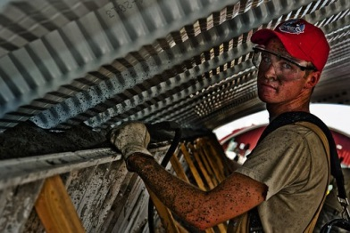

These are my three favourite jobs:
- _______________________________
- _______________________________
- _______________________________

Of these three jobs
______________________________________ is the one I‘d like to gain more information about.

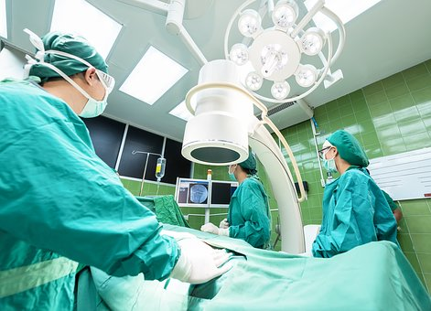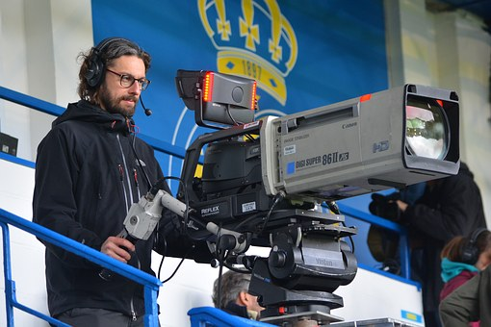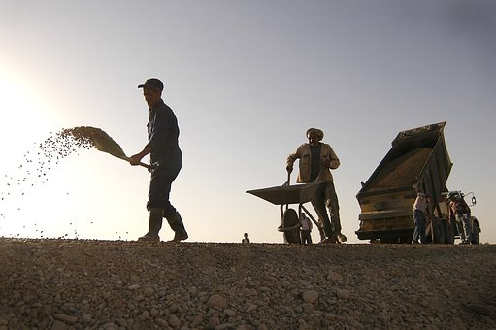
Bildquellen:
https://pixabay.com/en/coffee-shop-barista-cafe-worker-1209863/; https://pixabay.com/en/tie-necktie-adjust-adjusting-man-690084/; https://pixabay.com/en/construction-worker-concrete-646914/;https://pixabay.com/en/progress-clinic-medical-care-for-1807543/; https://pixabay.com/en/man-filming-camera-cameraman-job-1355509/; https://pixabay.com/en/construction-workers-shovel-1717905/

Which job do you find interesting? Read the texts and tick your favourite one.
Tick here: | picture | definition
 | 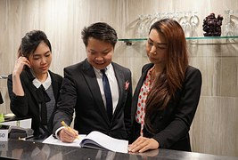 https://pixabay.com/en/manager-hospitality-training-1507506/ | Hotel receptionist  Hotel receptionists make guests feel welcome, manage room bookings (reservations) and deal with requests from guests.
 | 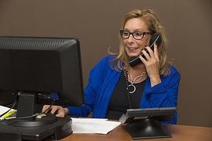https://pixabay.com/en/secretary-office-sales-telephony-544180/ | Secretary  Secretaries provide administrative support for all types of organization. They make sure that directors follow company law and financial regulations.
 | 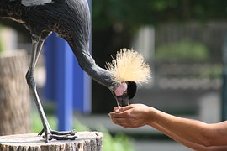  https://pixabay.com/en/bird-zoo-nature-animal-wild-1020952/ | Zookeeper  Zookeepers feed, clean up after animals and provide suitable entertainment for the animals in zoos.
 | 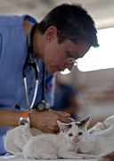  https://pixabay.com/de/k%C3%A4tzchen-tierarzt-katzen-arzt-pelz-569873/ | Vet  Vets diagnose and treat sick animals. They perform operations on animals and carry out tests and checks.
 | 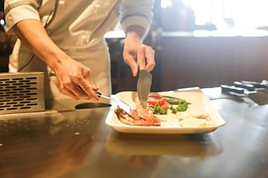https://pixabay.com/en/restaurant-cooking-chef-kitchen-1284351/ | Kitchen assistant  Kitchen assistants help to prepare food in big kitchens, unload deliveries, organize the store room and clean the kitchen.
 | 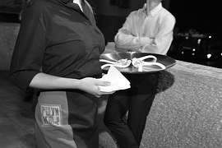  https://pixabay.com/en/waiter-virtual-reality-work-1569807/ | Waiting staff  A waiter or a waitress shows customers to the table, hands them the menu and serves food and drinks. They deal with bills and make sure that the tables are clean after the meal.
 | 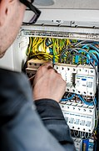  https://pixabay.com/en/electrician-electric-electricity-1080573/ | Electrician  Electricians install, fix and check power systems, lighting, fire protection, security, electric motors and data-network systems. They find and fix faults in electrical systems.
 | 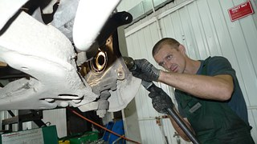  https://pixabay.com/en/mechanic-car-service-repair-346254/ | Motor mechanic  Motor mechanics find faults in cars often by using computer diagnostic equipment. They repair cars. They carry out standard servicing and safety checks.
 | 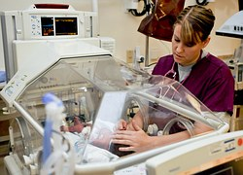https://pixabay.com/de/krankenschwester-milit%C3%A4rische-kinder-1796924/ | Nurse  Nurses look after sick patients and perform minor diagnoses. They help the doctors with physical examinations and give drugs and injections. They check on the patients’ progress.
 | 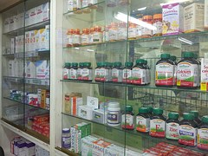  https://pixabay.com/en/pharmacy-medicine-food-supplement-218692/ | Pharmacist  Pharmacists prepare and sell medicines and give health care advice. They inform about the right dosage and sell health products too.
 |   https://pixabay.com/en/doctor-write-prescriptions-784329/ | GP (Doctor)  General Practitioners (GPs) are doctors who provide medical services to people in their practice. They make diagnoses, prescribe medicine and carry out minor surgery.
 | https://pixabay.com/en/make-up-make-up-artist-applying-791293/ | Make-up artist  Make-up artists apply make-up and style hair for people appearing on camera or in front of a live audience. They design make-up, hairstyles, carry out designers’ ideas and redo looks.
 | 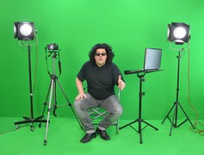  https://pixabay.com/de/greenbox-regie-regisseur-anweisung-959839/ | TV or film director  They create and direct films for TV or the cinema. They plan filming schedules and resources, develop scripts for programmes, hire cast and crew, direct actors on set and edit films.

